Skin Disease Detection Prediction Using Convolution Neural Networks

1st Bharath karingula 2nd Dileep kumar 3rd Tharun tej

***Abstract*—Skin is the most powerful protection of important organs in the human body. It acts as a shield to protect our internal body to get damaged. But this important part of the human body can be affected by so serious infections caused by some fungus or viruses or even dust too. Around the world, millions of people suffer from various skin diseases. From acne problems to eczema people suffer a lot. Sometimes a small boil on the skin can turn into a severe issue or even an infection that will cause a major health issue. Some skin issues are so contagious that one can be affected by another just with a handshake or using a handkerchief. A proper diagnosis can result in proper medication that can reduce the miseries of the people suffering create awareness. In this research, we have tried to develop a prototype to detect skin diseases using neural networks. In the choice of neural networks, we have chosen CNN which abbreviates as a convolutional neural network. Earlier detection works have been done using DNN which is a deep neural network. Right now have classes to identify a typical skin malady called dermatitis hand, eczema hand, eczema subcute, lichen simplex,statis dermatitis and ulcers. This paper is a sandwich between picture handling strategies and machine learning. Where picture preparation has produced the picture which is being utilized by CNN to arrange the classes. The preparation information comprises five classes of the skin gives that have been talked about above.**

***Index Terms*—Convolutional neural networks, picture han- dling, eczema, lichen, dermatitis**

1. Introduction

Skin is a part of our body that is not separable. It protects our kidney, heart, liver, and other sensitive organs from the outside environment. This part of the body is a shield that needs to be protected to ensure a healthy lifestyle. Skin pro- duces various vitamins the vital one is vitamin- D. If this part of our skin gets infected then that became the worst. Around the world, we have various types of weather, environment different type of weather conditions, humidity, food habit they can directly or indirectly affect our skin. To solve any problem that could be mathematical, science, economics we need to detect the problem first. To treat our skin first we need to identify the disease first. Skin can be affected by fungus and cause different kinds of fungal infections. Suffering from skin issues is common in our day to day life as we have to spend a long time outside under the sun or into the pollution that

https://github.com/MythreyiNalluri/Final DL Project https://github.com/Rithvikreddy7277/DL-final-project https://github.com/vxr22100/DL Final Project https://github.com/VarnaNemulla/DL-Final-Project-Increment

causes sweat which is a house of bacteria that creates bad smell along with some skin problems. Maintaining proper hygiene is a punch in the face of the skin issue. But some issues turn out to be vital that need proper identification with medication. The identification tool is our production. We have topped CNN over image processing to introduce a development in the field of medicine which we have named Derm-NN. It is an application of a convolutional neural network to detect skin disease. In this research, we have made a classifier prototype that will give the class of skin disease by analyzing an image and matching the image from its previous training data to produce maximum accuracy. In this test, we have used the dermnet dataset some images are collected from the internet randomly. Our classifier can accurately classify 70% of skin diseases. We have specified five classes of skin disease. We have used a part of our dataset for the training phase and also for the testing phase. The disease is an odd state of body where the natural functionalities of the body get to be stopped due to some imbalance on the body organs. Eczema is a skin condition where the skin became irritated due to the attack of some bacteria that inflame the skin and cause redness, itchiness some blisters too [1]. The convolutional neural network has proven its niche in the sector of computer vision and machine learning. It belongs to a class of neural networks. It has a great hold on the field of image processing. Visual imaginary classification is done with it. In this paper, we have created a classifier that will take input of an image that contains the contaminated skin image with its prior knowledge or could be referred to as the training data the classifier will determine its class. All the class information their accuracy and their result analysis have been given in the other parts of the paper. Skin disease has not been astounding until now. We motivate to do this study to create the cognizance about the issue. Their upshot on the skin can be dangerous over time [2]. In this digital era where the doctors are even digitally exploring patients through google glass technology, digitization should touch the fields of skin issues also. Here right now propose a mechanized framework that is incorporated with PC vision procedures that will help the patient to get exact data about their skin utilizing their cell phone or PC program.

Our inspiration for this paper is to give patients access to assistance from anyplace which will distinguish the ailment promptly for serving their requirements Restrictions apply. on compelling administration of ailment. First, they will snap a

photo of the contaminated region of their skin and transfer it in our framework The transferred pictures of illness will be handled in the focal server and it will answer with the sickness name skin has on the off chance that it matches with five in- fections it was prepared on [3]. Convolutional neural network (CNN) have been applied in this study for the identification of five skin diseases named: eczema hand eczema nummular, eczema subcute, lichen simplex, Stasis dermatitis, and ulcers. It is possible to make this an autonomous system for disease identification and providing suggestions based on the image analysis report, that takes this step for solving problems.

1. Related work

The amalgamation of technology with health care results in rapid development in image processing techniques to aid the medical field. Application of digital image-based equipment such as Computed Tomography (CT), Digital Subtraction Angiography (DSA), and Magnetic Resonance Imaging (MRI) help in accurate diagnosis. Many researchers have worked for detection of skin diseases so far. A brief literature survey is given below.

Ercal et al. [1] used an adaptive color metric from the RGB planes. It helps in discriminating the tumor and the background. Image segmentation is performed using a suitable coordinate transformation. Borders are drawn by extracting the tumor portion from the segmented image. This was an effective method to find tumors diagnosis.

S. Pari et al., [2] used deep convolutional neural networks, image classification algorithms with data augmentation to successfully investigate automatic detection of dermoscopic patterns and skin lesion analysis.

Ganster et al. [3] developed a computer-based system for image analysis acquired through ELM. Basic segmentation algorithms with fusion strategy are used to get the binary mask of skin lesion. The malignancy of lesion is calculated based upon shape and radiometric features. The local and global parameters are also considered for better results. The system improves the early detection of malignant melanoma.

Grana et al. [4], provided a novel mathematical approach to assess the lesion boundary. The approach considers luminance values along a direction normal to the contour at each point. Sigurdsson et al. [5] classified skin lesion based on in vitro Raman spectroscopy. They used a nonlinear neural network classifier for their work. Unique bands in spectrum show explicit lipids and proteins which provides information to

diagnose skin lesions.

Aberg et al. [6] uses electrical bioimpedance to assess skin cancers and lesions. Multi-frequency impedance spectra are used to separate skin cancer and benign nevi.

Wong et al. [7] proposed a novel iterative stochastic region- merging approach to segment skin lesion regions from the macroscopic images. In this approach initially, stochastic re- gion merging is performed on a pixel level, and afterwards on a region level until convergence.

Wighton et al. [8] performed automated skin lesion di- agnosis. A model based on supervised learning and MAP estimation are presented for the diagnosis.

Emre Celebi et al. [9] uses ensembles of thresholding methods to detect lesion borders in dermoscopy images.

Oyola and Arroyo [10] collected and classify an image of varicella through Hough transform and applied the color transformation, equalization and edge detection techniques of image processing. It helps in better diagnosis of varicella detection.

1. Motivation

Skin Cancer is an emerging global health problem consider- ing the increasing prevalence of harmful ultraviolet rays in the earth’s environment. A proper diagnosis can result in proper medication that can reduce the miseries of the people suffering and create awareness. In this research, we have tried to develop a prototype to detect skin diseases using neural networks.

1. Objectives

This paper is focused on evaluating Convolutional neural networks in predicting skin disease using an image as input

* To design an effective neural network model that best classifies the given input user image to the most accurate skin disease.
* To develop a UI with ease of use for the users using the programming components and modules available in Python.

1. Proposed frame work

Our approach started with loading of the dataset and then the data augmentation continued by creating a neural network and training the network. The flow is as below.

1. *Dataset Collection*

The pictures from Dermnet. We have considered skin in- fection pictures with the natural parts. It has been seen that the proposed framework yield exactness differs as for skin illnesses. The five unique infections which we considered are

:

* + 1113 Melanoma images
  + 1099 Benign keratosis images
  + 514 Basal cell carcinoma images
  + 327 Actinic keratosis images
  + 115 Dermatofibroma images

1. *Data augmentation Preparation*

To avoid overfitting we are extending our data using data augmentation. In any case, our profound neural classifier needs a comparable informational index for preparing and testing the informational index. So we set the pixels into 100 X 100. At that point, we have changed over into the picture grayscale to prepare our model. We utilize the lower GPU in our PC. Our all-out picture number after growth is 3000. We utilize 2400 pictures for preparing and 600 for testing.

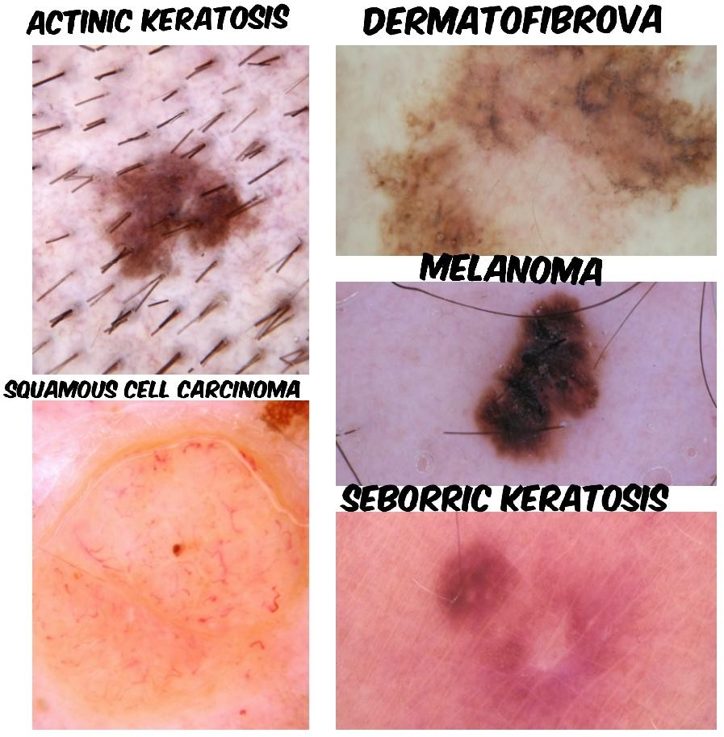

Fig. 1. Considered types of skin diseases

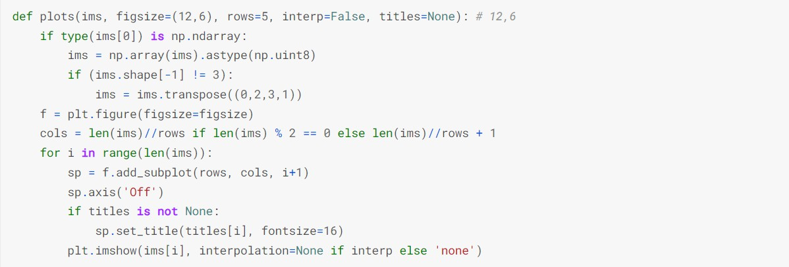

Fig. 2. Data augmentation

1. *Splitting data for training and validation*

Here in this section we used the sklearn module in python to split our numerical tabular dataset into 2 with 80 percent as training data and remaining as validation data.

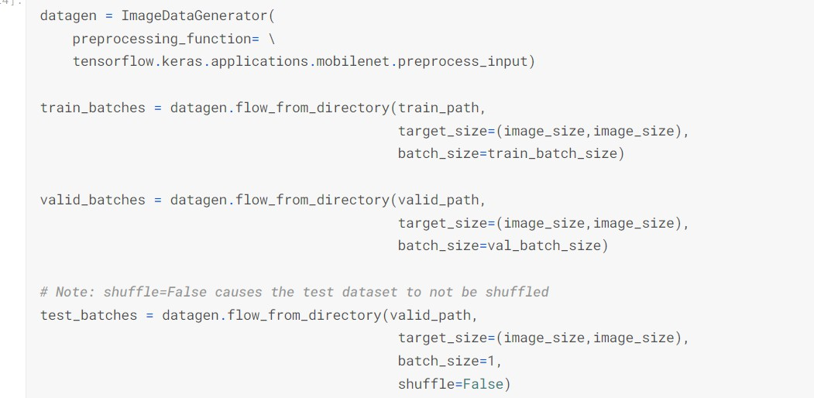

Fig. 3. Test and train split of data

1. *Model building*

After the segregation of the image data into training and validation set using image data generators, we have focused on model building. We are building a neural network model with 13 layers in it. And the layers of information are as below:

* + The first layer has 32-3 × 3 filters and ‘linear’ as an activation function.
  + The second layer has 64-3 × 3 filters and ‘linear’ as an activation function.
  + The third layer has 128-3 × 3 filters and ‘linear’ as an activation function.
    - The fourth layer has 256-3 × 3 filters and ‘linear’ as an activation function.

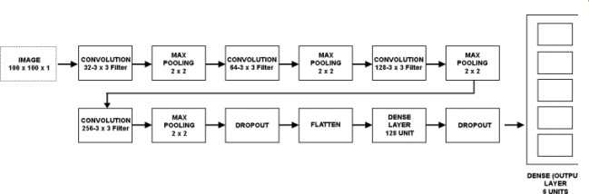

Fig. 4. CNN architecture

We used Adam Optimizer for the compilation of our model. Our classifier’s batch size is 64. 40 epochs were used by us to train the model

1. Results and Analysis

In the scope of evaluating the model, here we considered the training and validation accuracy. Preparing precision is considered as the exactness of the model which is applied to our preparation information. The figure shows a diagram that contains the preparation and approval of exactness.

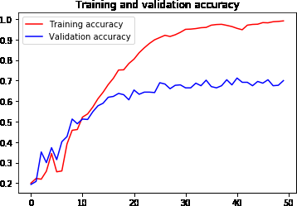

Fig. 5. Training and Validation accuracy of the model

Accuracy, Recall, and F1-score have been determined from our test dataset which contains 600 pictures. So we can say that out Precession normal is 0.70, Recall normal is .70 and F1- score normally us 0.69. Finally, we can say that our classifier is quite acceptable. Characterization table is given underneath: From the table of classification report, we can see that the classifier accomplished a tolerable precision, which is 70%. We got total precision of about 0.93. The total recall value is 0.88. The total accuracy we got 0.73 where the F1-score was 2.45. The result we got is for the five classes we have determined. The recall value for the classes ranges to 0.56 to

0.9. We portray the presentation of our model by hardly any figures Shows the disarray grid without standardization and Show the standardized disarray framework.

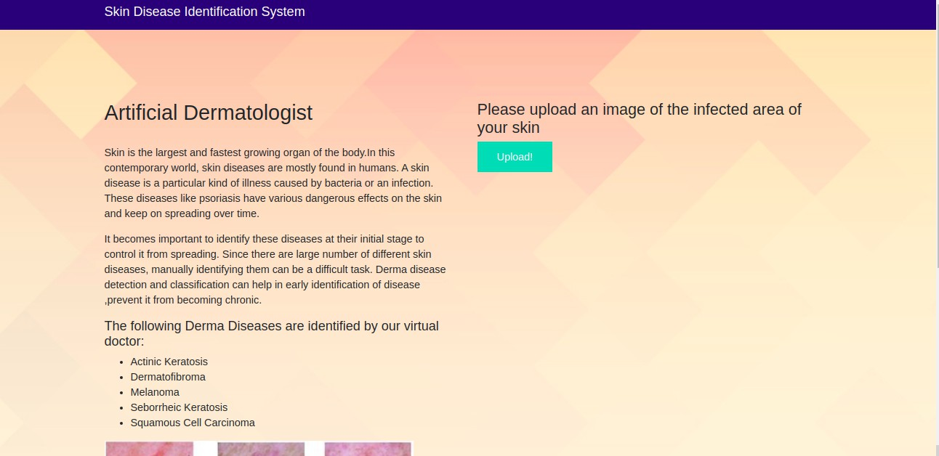

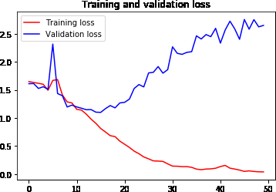Fig. 6. Training and Validation loss of the model

1. *Confusion Matrix*

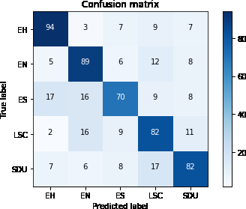

Fig. 7. Confusion matrix

Fig. 9. Home Page in the Interface

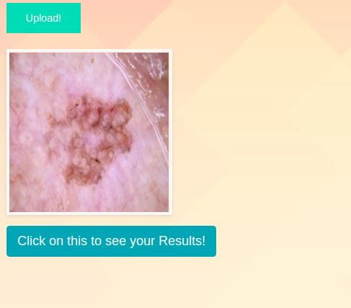

Fig. 10. Uploading the test image

The prediction of the model to the most nearest class do the input image belongs to

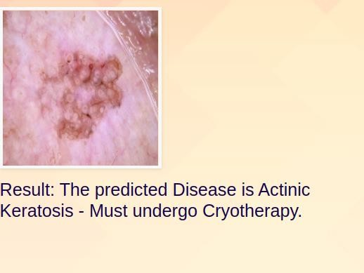

Fig. 11.

1. *Interface*

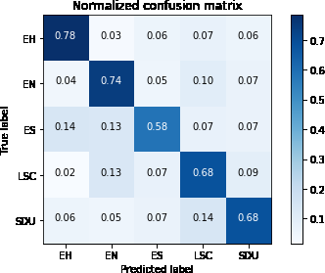Fig. 8. Normalized Confusion matrix

Conclusion

The digitalized skin ailment pictures were caught by the camera and preparing strategies were applied to these in- formation pictures. Picture handling is a strategy that can be partitioned into various classes: one of these is Image Compression another picture upgrade and the latter is the reclamation, and estimation extraction. We trust that this model will be created as a genuine application for our clinical science for the government assistance of patients. It will be so encouraging for created nations to identify their sicknesses so they can concern prior and can make legitimate strides for

We developed an interface using Flask and binded the best model for the prediction of Skin disease using the trained

their sound skin.

References

convolutional neural network model. The main page or home page of the interface is as below.

1. “Eczema:symptoms,treatment and causes.” [Online]. Available: [https://www.medicalne](http://www.medicalnewstoday.com/articles/14417)wstoday[.com/articles/14417](http://www.medicalnewstoday.com/articles/14417)
2. ] S. Paris, “A gentle introduction to bilateral filtering and its applica- tions,” in ACM SIGGRAPH courses, pp.
3. Z. Zakaria, N. A. M. Isa, and S. A. Suandi, “A study on neural network training algorithmfor multiface detection in static images,” International Journal of Computer and Information Engineering, vol. 4, no. 2, pp. 345–348
4. A. Esteva, B. Kuprel, R. A. Novoa, J. Ko, S. M. Swetter, H. M. Blau, and S. Thrun, “Dermatologist-level classification of skin cancer with deep neural networks,” Nature, vol. 542, no. 7639, pp. 115–118,
5. V. Bindhu, “Biomedical image analysis using semantic segmentation,” Journal of Innovative Image Processing (JIIP), vol. 1, no. 02, pp. 91– 101,
6. T. Vijayakumar, “Comparative study of capsule neural network in various applications,” Journal of Artificial Intelligence, vol. 1, no. 01,

pp. 19–27, 2019.

1. H. Liao, “A deep learning approach to universal skin disease classifica- tion,” University of Rochester Department of Computer Science, CSC,
2. A. Pal, A. Chaturvedi, U. Garain, A. Chandra, and R. Chatterjee, “Severity grading of psoriatic plaques using deep cnn based multi-task learning,” in 2016 23rd International Conference on Pattern Recognition (ICPR). IEEE, 2016, pp. 1478–1483.
3. E. Balestrieri, F. Lamonaca, S. Lembo, G. Miele, F. Cusano, and G. A. De Cristofaro, “Automatic psoriasis assessment methods: current sce- nario and perspectives from a metrologic point of view,” in 2019 IEEE International Symposium on Medical Measurements and Applications (MeMeA). IEEE, 2019, pp. 1–6
4. Z. Ge, S. Demyanov, R. Chakravorty, A. Bowling, and R. Garnavi, “Skin disease recognition using deep saliency features and multimodal learning of dermoscopy and clinical images,” in International Conference on Medical Image Computing and Computer-Assisted Intervention. Springer, 2017, pp. 250–258